SLE-3: Architectural Design (Full C4 Model)
Course: 02AML204 – Introduction to Artificial Intelligence
PRN: 25UAM102
Name: Shubham Khavare
Division: B
Date: 4 October 2026
GitHub Link: https://github.com/shubhamkhavare61-netizen/IAI_SLE3_Architectural-Design

1. System Title & Short Description
4-Queens Solver: BFS vs DFS. The 4-Queens problem asks us to place 4 queens on a 4×4 chessboard so that no two queens attack each other (no shared row, column or diagonal). The system models each partial board as a state and searches the state space with Breadth-First Search (BFS) or Depth-First Search (DFS). It returns the queen positions, counts the nodes expanded and measures the run time, so the two strategies can be compared on the same problem.

2. Context Diagram (Level 1)
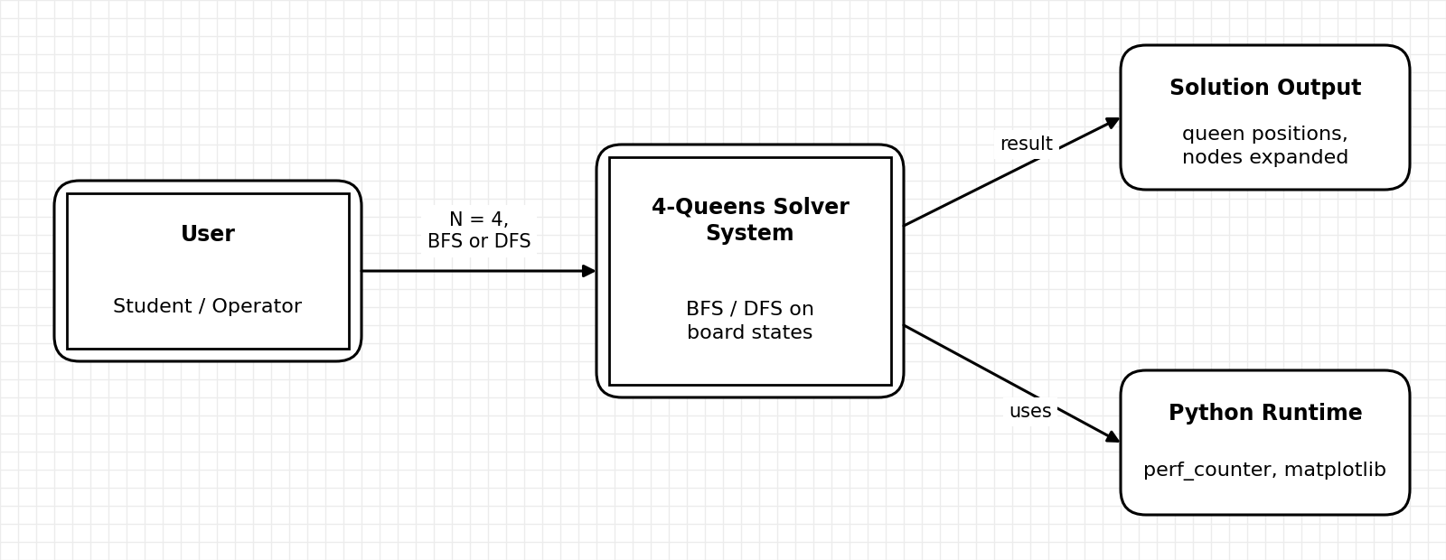
The User gives the board size (N = 4) and chooses BFS or DFS. The 4-Queens Solver System returns the queen positions, the number of nodes expanded and the run time. It depends only on the Python runtime (time.perf_counter for timing, matplotlib for charts), so there are no other external systems and the context stays simple.

3. Container Diagram (Level 2)
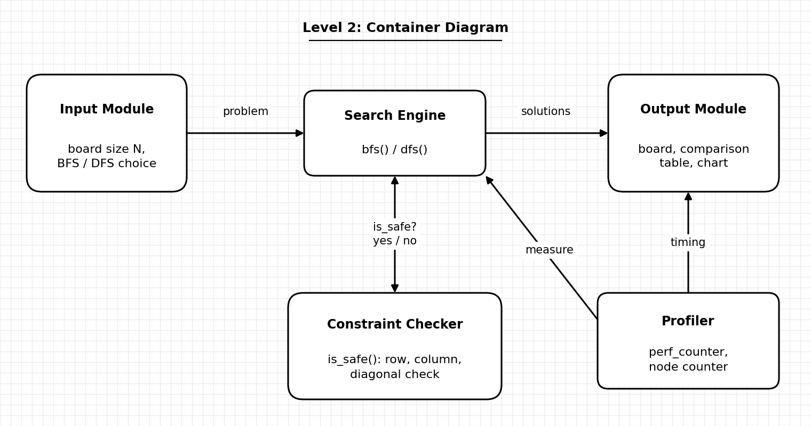
- Input Module: takes N and the algorithm choice (BFS or DFS) from the user.
- Search Engine: runs bfs() or dfs() over the board states and decides when a full solution is reached.
- Constraint Checker: is_safe() tests that a new queen does not share a row, column or diagonal with the queens already placed.
- Profiler: counts nodes expanded and measures run time with perf_counter.
- Output Module: prints the board, the comparison table of BFS vs DFS and the chart.

4. Component Diagram (Level 3)
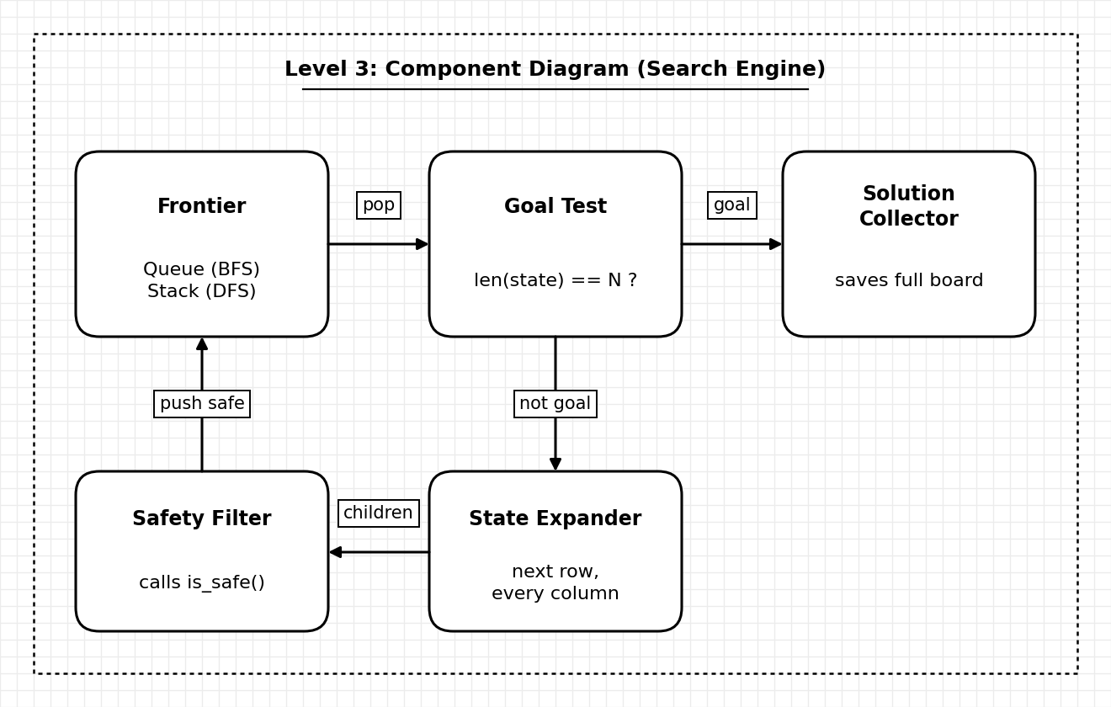
I chose the Search Engine because it holds the core logic. The Frontier is a queue for BFS and a stack for DFS, and this is the only real difference between the two algorithms. The Goal Test checks whether a state has N queens. If not, the State Expander creates child states by placing a queen in the next row in every column, and the Safety Filter (using is_safe) drops the unsafe ones. Safe states go back to the Frontier, and complete boards are stored by the Solution Collector.

5. Code Level Overview (Level 4)
- is_safe(state, row, col) : checks column and diagonal conflicts for a new queen.
- goal_test(state) : returns True when the state holds N queens.
- expand(state, n) : generates child states for the next row.
- bfs(n) : queue-based search; returns solutions and nodes expanded.
- dfs(n) : stack-based search; returns solutions and nodes expanded.
- profile_run() : runs each algorithm and records average time and node count.
- print_board() / plot_chart() : display the board and the comparison chart.

6. Design Decisions
I split the system into 5 containers so each part has one job: input, search, constraint checking, measurement and output. is_safe() is kept separate so the same rule is used by both BFS and DFS, which keeps the comparison fair. BFS and DFS share the same structure and differ only in the Frontier (queue vs stack). The Profiler is separate from the search code so timing does not change the algorithm. A state is just the list of column positions, one per row, which is small and easy to copy.

7. AI Contribution Note
- AI tools used: Claude (Anthropic).
- What AI helped with: drafting the C4 diagrams, the report layout and the wording of the explanations.
- What I did myself: chose the 4-Queens BFS vs DFS system from my own repository, checked that the containers, components and function names match my code, and I can explain each design choice.

8. Conclusion
This task showed me that architecture is about dividing a system into clear parts and showing how they connect. The four C4 levels let me move from the big picture (user and system) down to individual functions without getting lost. I also learned that BFS and DFS differ only in how the Frontier is handled, and that keeping search, constraint checking, profiling and output separate makes each part easy to change and test on its own.

